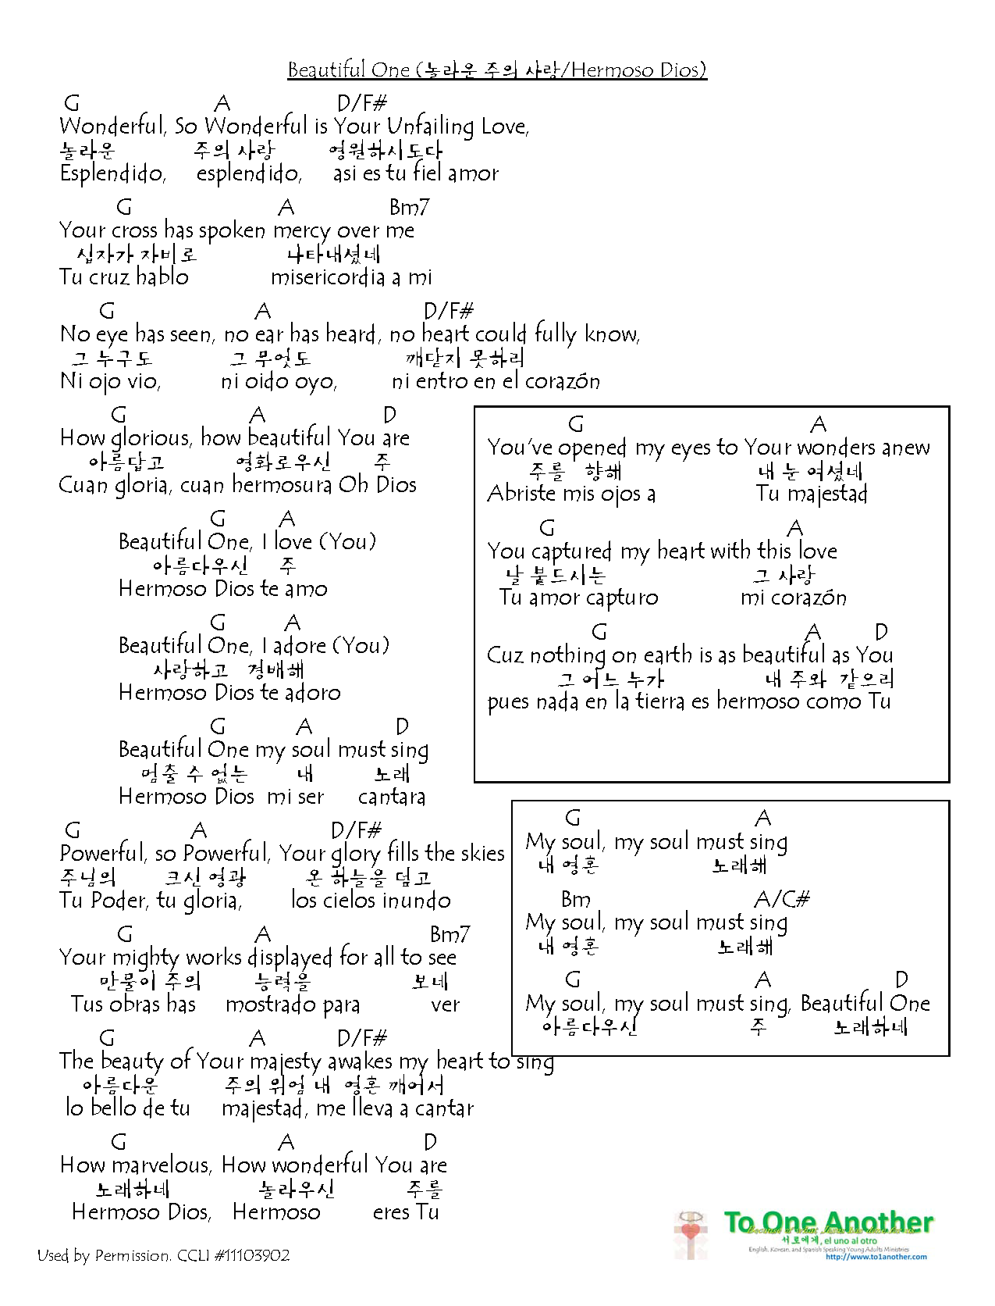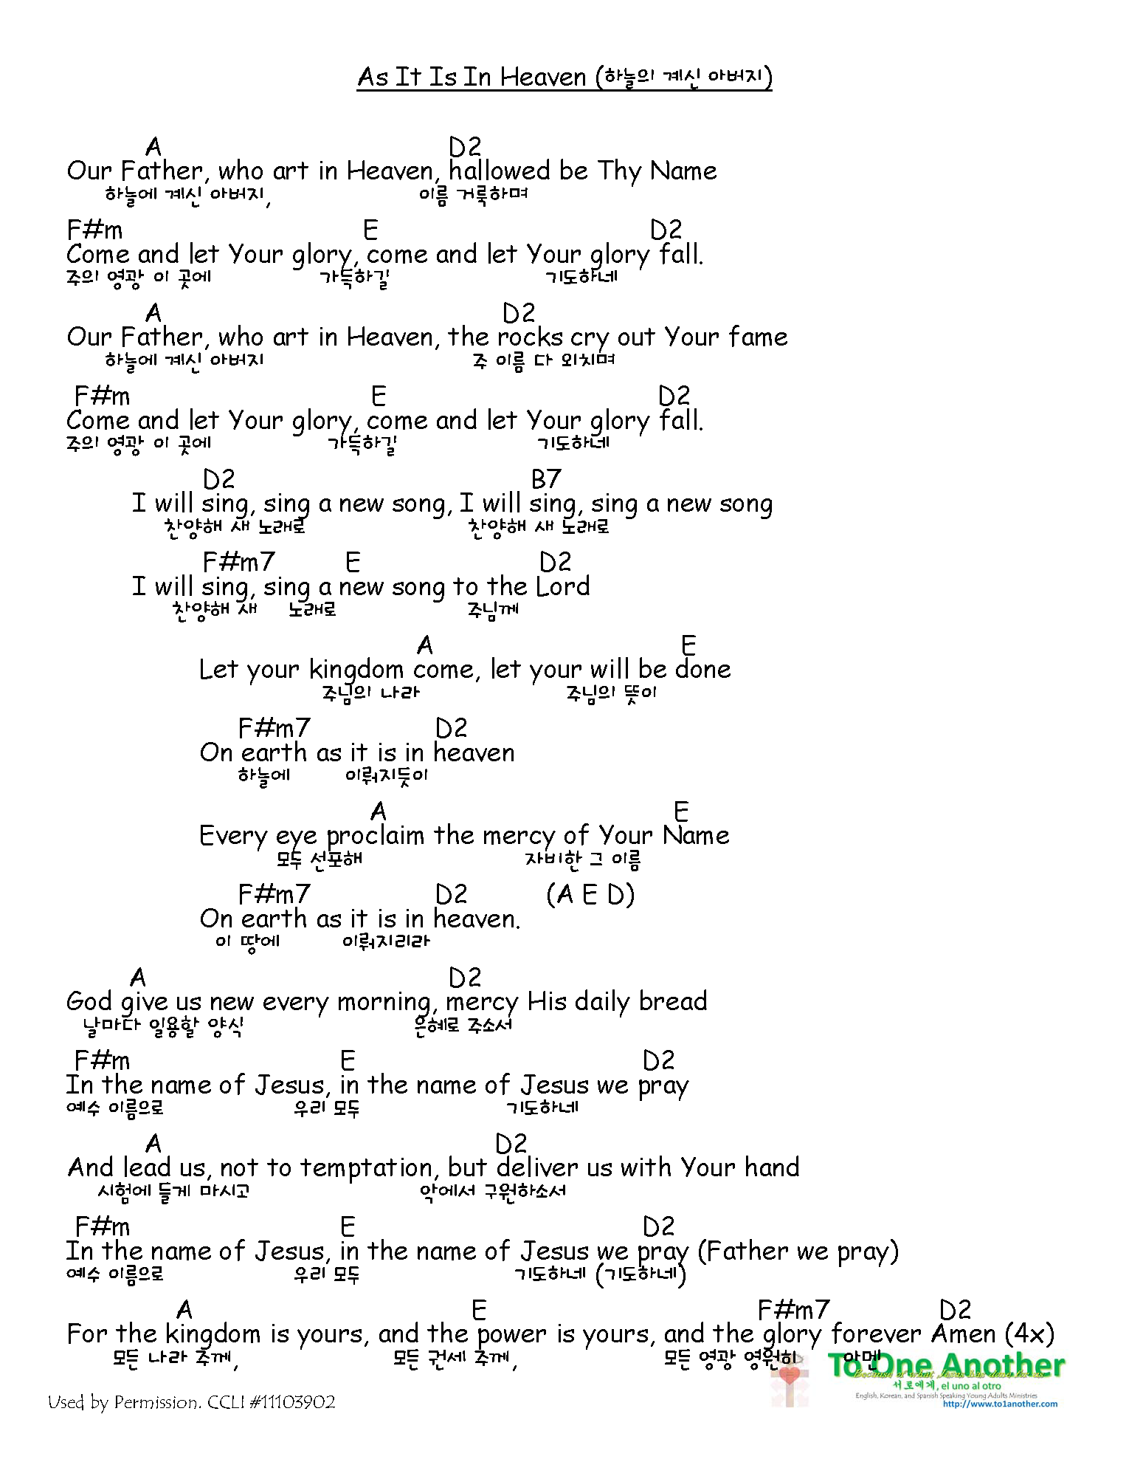

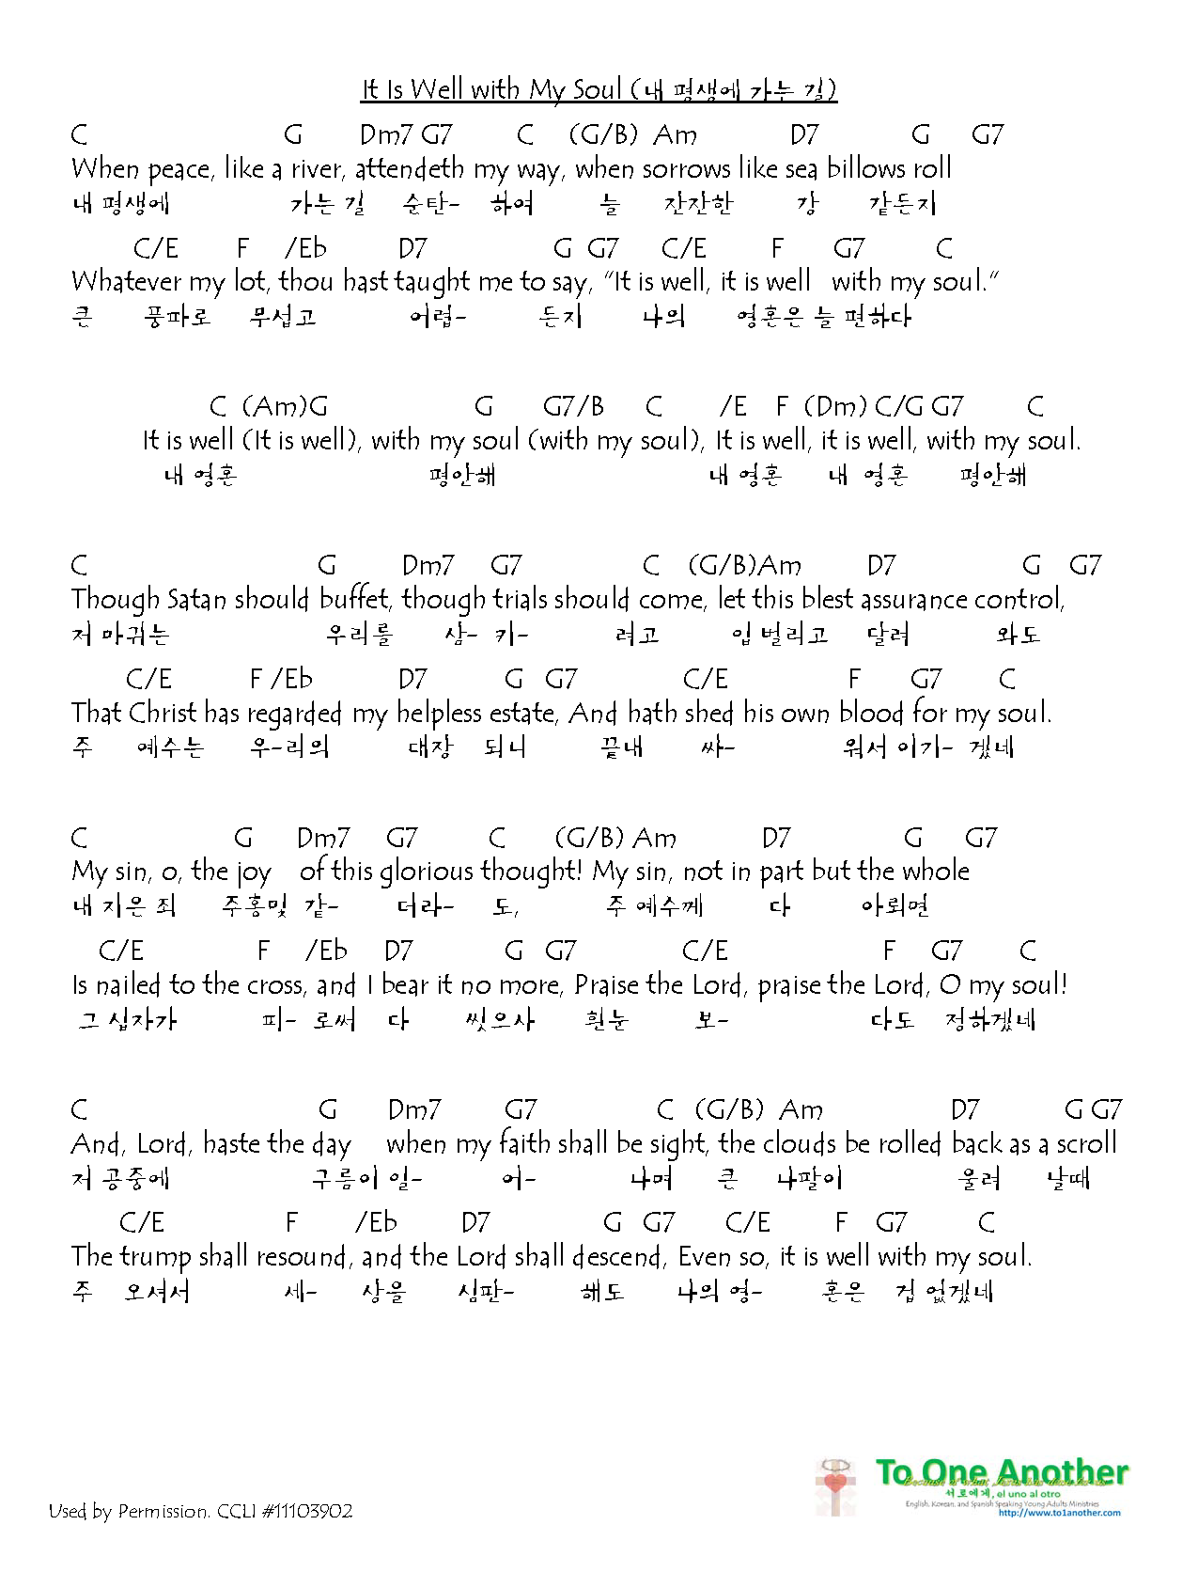

Summary of Ephesians (에배소서 줄거리):
It is God’s will to have a relationship with us (1-2) – both individually and collectively. Collectively, we are called the Church. The relationship God has with us is modeled by marriage (5:21-33) – Jesus is the groom, and the Church is the bride. Jesus is, therefore, the head of the church, and we are to follow Him in obedience and submission – as He will guide us to the best path (1:22, 4:15). To do this collectively, we, together, must be unified in our minds and in the direction we are going. This requires us to be alert and aware when our Head speaks to us (4:13) and at the same time be in harmony with one another (4:3) so we can move together. This calls for unity of believers – of the church.
하나님은 우리와 관계를 갖는 것이 하나님의 뜻입니다 (1-2) – 개인적으로와 공동으로. 공동체로서는 우리가 교회라고 합니다. 이 관계를 결혼으로 상징합니다 (5:21-33) – 예수님이 신랑이시고 우리가 신부가 되는 것입니다. 그러므로 예수님이 교회의 머리(대장)이 되는 것입니다. 그리고 우리는 순종으로 따라야 우리의 좋은 신랑이 준비해준 가장 좋은 길로 갈 수 있는 것입니다 (1:22, 4:15). 공동체로서 따르길 위해서는 우리가 한 마음이 되어야 하고 한 방향으로 움직여야 됩니다. 이것을 이루기 위하여 우리의 신랑의 음성을 구분할 수 있어야 되며 (4:13), 서로와 화목해야 우리가 함께 움직일 수 있습니다(4:3). 믿는자들이 공동체로서 (교회로서) 하나가 되어야 (합력해야) 합니다.

Ephesians 1 - The church exists because of Jesus
Ephesians 2 - God's grace saves us and unites us
Ephesians 3 - Gospel -- Jesus has united us and formed the church - It's about each other
Ephesians 4 - Now, live in unity with one another - lead a life worthy of your calling
Ephesians 5:1-15 – So live a life that is worthy of follower of Jesus
Ephesians 5:15-20 - Live for benefit of others
Ephesians 5:21-32 - Live for the benefit of spouse
Ephesians 6:1-3 - Live for the benefit of your parents
Ephesians 6:4 - Live for the benefit of your children
Ephesians 6:5-9 - Live for the benefit of those that are over you
Ephesians 6:10-18 - Remain in the Lord; defend yourselves so you can live this way (Whole Armor of God)

1:12 God’s purpose was that we Jews who were the first to trust in Christ would bring praise and glory to God. 13 And now you Gentiles have also heard the truth, the Good News that God saves you. And when you believed in Christ, he identified you as his own by giving you the Holy Spirit, whom he promised long ago. 22 God has put all things under the authority of Christ and has made him head over all things for the benefit of the church. 23 And the church is his body; it is made full and complete by Christ, who fills all things everywhere with himself.

2:17 He brought this Good News of peace to you Gentiles who were far away from him, and peace to the Jews who were near. 18 Now all of us can come to the Father through the same Holy Spirit because of what Christ has done for us. 19 So now you Gentiles are no longer strangers and foreigners. You are citizens along with all of God’s holy people. You are members of God’s family. 20 Together, we are his house, built on the foundation of the apostles and the prophets. And the cornerstone is Christ Jesus himself. 21 We are carefully joined together in him, becoming a holy temple for the Lord. 22 Through him you Gentiles are also being made part of this dwelling where God lives by his Spirit.

3:10 God’s purpose in all this was to use the church to display his wisdom in its rich variety to all the unseen rulers and authorities in the heavenly places. 11 This was his eternal plan, which he carried out through Christ Jesus our Lord. 12 Because of Christ and our faith in him, we can now come boldly and confidently into God’s presence.

4:1Therefore I, a prisoner for serving the Lord, beg you to lead a life worthy of your calling, for you have been called by God. 2 Always be humble and gentle. Be patient with each other, making allowance for each other’s faults because of your love. 3 Make every effort to keep yourselves united in the Spirit, binding yourselves together with peace.
11 Now these are the gifts Christ gave to the church: the apostles, the prophets, the evangelists, and the pastors and teachers. 12 Their responsibility is to equip God’s people to do his work and build up the church, the body of Christ. 13 This will continue until we all come to such unity in our faith and knowledge of God’s Son that we will be mature in the Lord, measuring up to the full and complete standard of Christ.
16 He makes the whole body fit together perfectly. As each part does its own special work, it helps the other parts grow, so that the whole body is healthy and growing and full of love.
31 Get rid of all bitterness, rage, anger, harsh words, and slander, as well as all types of evil behavior. 32 Instead, be kind to each other, tenderhearted, forgiving one another, just as God through Christ has forgiven you.

5:1Imitate God, therefore, in everything you do, because you are his dear children. 2 Live a life filled with love, following the example of Christ. He loved us and offered himself as a sacrifice for us, a pleasing aroma to God.

